PD22 GPS Tracker Manual

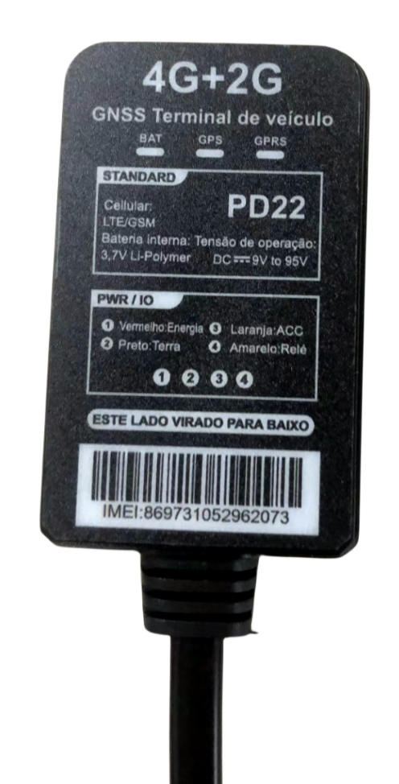

Welcome to use our product, please read this manual to install and operate the terminal exactly. This user manual is for reference only. If some contents and operation steps are inconsistent with those for the actual product, the latter will prevail.

- Product Introduction

PD22 GPS tracker is used for position,remote monitor and control the vehicle on the position server via GPRS, GPS. It can help customers to manage transparently, reduce cost, maintain security and raise efficiency. Now it is widely used in business traffic, logistics distribution, automobile lease, intelligent transportation, shipping market, army and police, rescuing, Safet Supervision, Intelligent city.
2．Product Features
- Supports 4G LTE communication band
- Real time tracking
- History track playback.
- Web browser platform, Smart phone app platform and SMS query.
- Built-in battery, even main power cutoff ,which still work
- Power disconnect alarm
- Low battery alarm.
- Built-in acceleration-Sensor, Support Vibration/ collision/ falling alarm.
- Supports ACC status checking
- vehicle status notifying.
- Use relay to remotely engine cutoff
- Multiple protocol s, OTA upgrade program.
3, Device Parameter
WorKing Voltage | 9- 90VDC
Work current | <63mA@12v
Standby Current | <10mA@12v
GPS accuracy | 5~10m
GSM accuracy | 100m
GPS Frequency | 1575MHz
Antenna size | 2 5* 25 *14mm
Position Accurate | <10m（1σ）
Timing Accurate | <30ns（1σ）
Testing Accurate | <0.1m/s（1σ）
Max Acceleration | 4g
Max Speed | 515m/s
Max Height | 18000m
GSM Frequency | B1/B2/B3/B4/B5/B7/B8/B28/B66 800/900/1800/1900mhz
Hot/warm/coldstart time | <3s，<32s，<45s
Battery capacity | 3000mA
Dimensions (mm) | 59*36*21mm
Operating temperature | -20℃~70℃
Operating humidity | 10%～85%RH

4. Components

4.1 Device With Wire

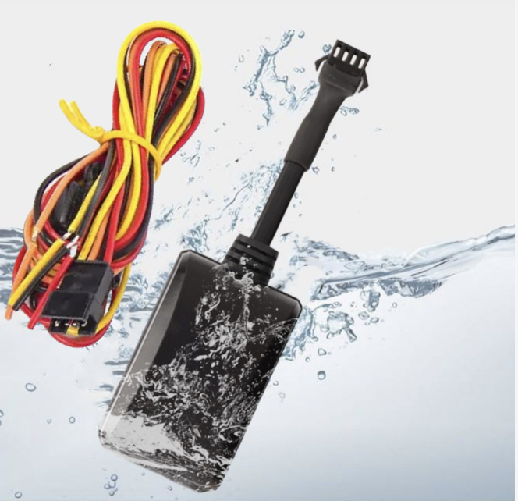

4.2 Optional Acessories
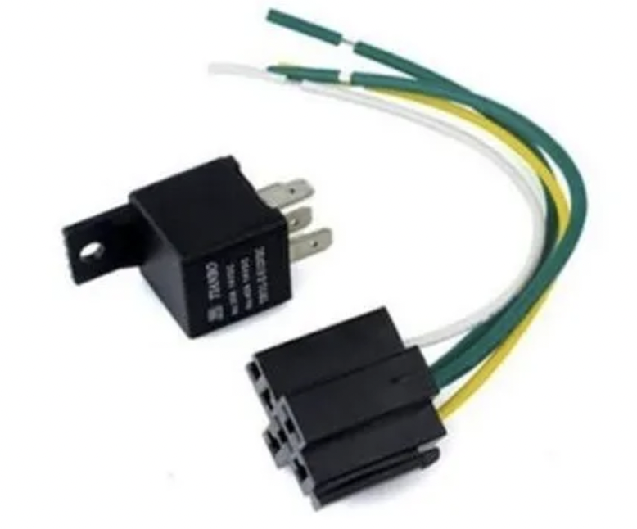
Relay is for remoting cutoff oil and power ,need work together with gps tracker

5. SIM card Installation

5.1 Before Installation
Open the packing case, then check if the terminal is OK and the accessories are intact, or please contact your dealer;

5.2Install the SIM card
You need a suitable SIM card for using the terminal, please contact your dealer if you have any question;

Note:
- Please cut off the power before installing or uninstalling the SIM card.
- The SIM card should support GPRS and the GPRS should be opening.
- Inquiry by call needs the SIM card supporting the calling line identification presentation.
- If you enable the PIN code of the SIM card, please use your mobile phone to disable the PIN code.
- Please make sure that the SIM card has sufficient balance.

6. Terminal Installation

6.1Install the terminal
Suggest to install the terminal concealed by the dealer designated professional body.

Installation Notice
- Hide the terminal properly inside the car body in order to avoid damages.
- Keep the terminal away from RF emission sources such as backing radar, car burglar alarm and other vehicle mounted communication devices.
- Suggest to use wide strong double-sided adhesive sponge to fix it, or use cable ties and other liable methods to fix it.
- Device Built-in GSM antenna and GPS antenna, Installation should ensure that the receiving side facing up (towards the sky) without metal cover on the top of it, otherwise may weaken the antenna signal, Cause the device to not work correctl

6.3 Recommend installation location
- The hiding place below the front windshield trim panel;
- The hiding place around the front dash(if the surface is not made of metal);
- The place under the rear windshield

7.Terminal Wiring Definition
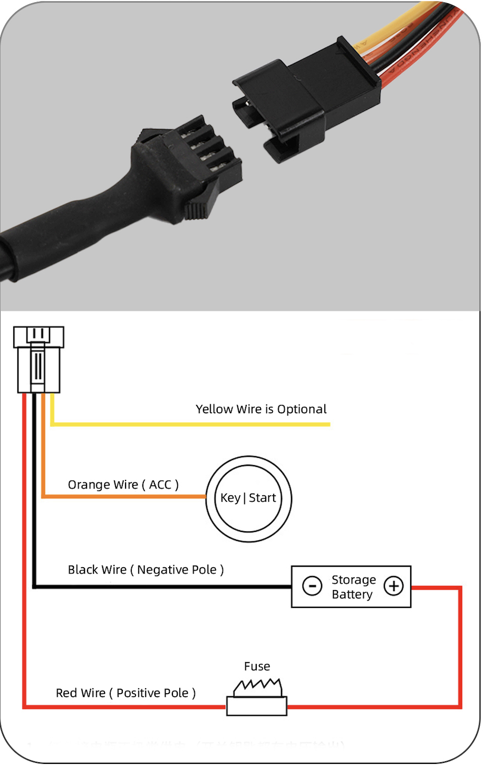

The standard input voltage of the terminal is
9-90VDC, so please choose the our original power cables, the red cable is positive and the black cable is negative; Please ground the negative pole separately or ground it to ground connection, not to any other ground.
Connect the ACC cable (orange cable) to ACC switch of the vehicle, then the position server can get the information about the vehicle power; the ACC cable can also be connected directly to the positive pole of the vehicle power, then the position server think that the vehicle is always ignited.
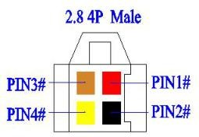
Connect the 4# cable (yellow cable) to the 86 terminal(with small yellow cable) of the relay. Use cable ties to fix the relay to waterproof place, or use plastic bags to cover the relay..

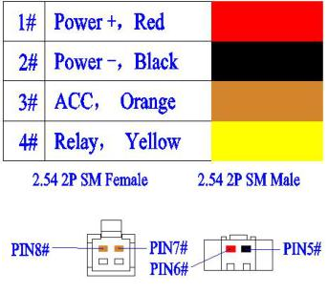

Relay wiring
Relay wiring diagram shows how to wire the relay to control the fuel pump:

1.Connect the 86 port to the positive pole of the vehicle power (+12V/+24V), connect the 85 port to the 4# cable (Yellow) of the terminal.
2.Cut off the positive pole of the fuel pump, next serial connects the positive pole to the 87a port of the relay, and connect another pole to 30 port, showing as in the figure.
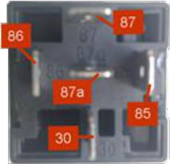
Bottom of Relay Wiring Diagram

Notice: Be sure that the voltage of the vehicle
power should match up to the working voltage of the relay, or the relay will be damaged.

8. Power on the terminal

8.1 Power on
Power on: insert a valid SIM card and wire all the cables, then the terminal power on itself.

8.2 LED Indicators
The red LED flickers fast when the terminal is searching for GSM network, it flickers intermittently when the terminal connect with GSM network successfully.
The blue LED flickers fast when the terminal is searching for the GPS satellite signal, it flickers intermittently when the terminal has searched the satellites and can be positioned

1.Yellow LED (indicates GSM working state)

Fast flicker | Searching for GSM network
Continuous | GSM/GPRS works normally
2.Blue LED (indicates GPS signal state)
Fast flicker | Searching GPS Satellites
Continuous | GPS works normally

8.3 Power off
Disconnect the external power and take off SIM card, after a while the terminal will shut down.

9.Inquiry/Monitor /Cut Oil

9.1 Inquiry by SMS
You can write a positioning SMS sending to the terminal to inquiry terminal position, the terminal will reply position SMS or map link. The SMS commands please refer to the Operation Commands

Inquiry byService Platform
9.2.1Web Browser platform
You can login the service platform and
enter your ID and password to check the position of your terminal. Ask your dealer about the URL of Web platform.

9.2.2 Smart phone applications platform
You can use a smart phone to check the terminal’s position. We have prepared for you the Android client (Android), Apple clients (IOS), please check with your dealer to get installation package.

9.3 Terminal Monitoring
9.3.1Monitoring by dialing terminal
When the setting administrator number (such as center number, administrator number) dial the terminal, the terminal will automatically connect the call after 8 seconds ring. Non-administrators can not monitor terminal by dialing, and this feature requires the terminal has the Caller ID.
9.3.2 Monitoring by Command
Sent monitor command to the terminal (see "Operating Instructions"), the terminal will cycle dial the number specified in the command for three times until getting through.

9.4 Cut off/recover oil circuits

9.4.1 Cut off oil circuits
Server(GPRS) or Center number (SMS) can send

cut-off fuel commands when needed. The fuel of the vehicle will be cut off on the premise of safety, and the vehicle will not be powered on.
To make sure the safety of the vehicle, the fuel of the vehicle will be cut off only if the terminal has positioned by GPS and the speed of the vehicle is less than 20KM/h or the vehicle is not moving.
9.4.2 Recover oil circuits
Server(GPRS) or Center number (SMS) can send recover-fuel-circuit commands to the terminal when needed, the terminal will recover the fuel circuits

10. Set Up Terminal

Please refer to <Operation Commands>

Vibration Alarm
Conditions: When the Vehicle Vibration occurs. Note: You need to set vibration sensitivity and time, there are arm / disarm switch.

10.2 Collision / falling Alarm
Conditions: When Vehicle Collision or falling occurs.

10.3 Alarm

Conditions: When the vehicle over and below the set speed.
Note: You need to set the low speed limit and high-
speed limit.

10.4 Geo-fence Alarm
Conditions: when the vehicle entry / exit / across the Geo-fence.

Note: You need to set the conditions of crossing fence, fence types and so on.

Power Disconnect Alarm
Conditions: When the device is disconnected from external Power.

Low Battery Alarm
Conditions: When the device is disconnected from external Power and built-in battery power falls below a certain value.

11. Trouble Shooting

11.1 Cannot connect the platform
If terminal is never online on the position server after installation, please check as below:
- If the power cables are wired correctly? Pay attention not connect them to the controlling cables of vehicle.
- If SIM card is installed correctly? Please refer to the installation instructions.
- Check status of the LED indicators. If the red LED and blue LEDintermittently flick.
- Inquiry the parameters of terminal via commands and check if parameters are correct.

11.2 Offline status on the platform
First check if LED indicators are OK, if cannot check them, you need to check the SIM card:
- call the SIM card of the terminal and check if you can hear a connecting ring.
- Check GSM signal of the area is OK or not.
- Check if one terminal or all terminals are offline
in the area in the same time. If all terminals are offline, you should check GSM network operator.
- Check if the SIM card has enough balance.
- If terminal becomes offline on the last day of one month, check GPRS service is still available or not.
- Inquiry the parameters of terminal via commands and check if parameters are correct.

11.3 Not positioning for long time
If GPS is active, but terminal cannot be positioned for long time, please check terminal:
1）Check GPS signal of the area is OK or not.
2）Upside of terminal face toward sky or not.

3）GSM and GPS signal may be weakened if the terminal is installed in the place with electromagnetic wave absorption material(such as metal blocks), lead to device can not be positioned.

11.4 Position drift
Serious position drift will be found in places where GPS signal is poor. Please drive the vehicle to the open places.

11.5 Commands receiving abnormally
- Check the commands format.
- Check if the vehicle is in the places where there is GSM signal.
- Check if the SIM card is properly installed.

12. Warranty Rules

12.1 Special statement
- Technology change without notice.

- If the color and appearance are inconsistent with those for the actual product, Please according to the actual device received.

- Warranty card is only valid for the terminals with the following IMEI.
- Please take care of the warranty card and show it with the original purchase receipts when enjoying the warranty service.

12.2 Warranty period
One year warranty from the purchase date if it is not artificially damaged.

12.3 After sales
Any of the following circumstances not covered by the warranty, but may be appropriate to pay repair:
1）More than the warranty period. 2）Unauthorized removal or repair damaged.
3）Damage caused by improper installation, use, maintenance, custody.
4）The IMEI label is torn or Obscure. 5）Warranty certificate and product models do not match or warranty certificate be altered.
6）Damage caused by force majeure

Warranty Card
NAME TEL
Address Model
IMEI Number
Purchase Date
YY MM DD

Maintenance Records
Date | Description | Records | Completion Date | Engineer

